 | 

 | Lecturers  European Trainers’ Commission  November 2024  April 2025 | 
GM Ivan Sokolov  Netherlands  Middlegame Strategy |  | GM Adrian Mikhalchishin  Slovenia  Pawn Structures
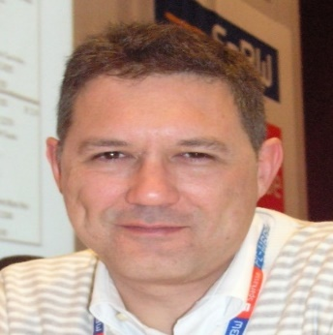 |  | 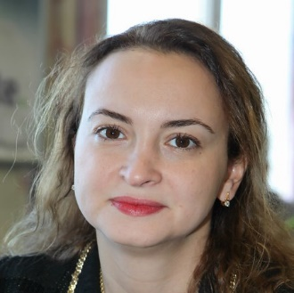
GM Miguel Illescas  Spain  Tactical World | GM Efstratios Grivas  Greece  Endgame Magic | GM Antoaneta Stefanova  Bulgaria  Playing on the Top
 | 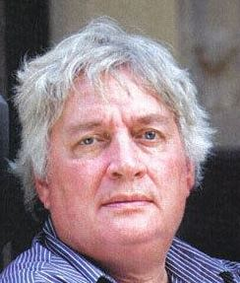 | 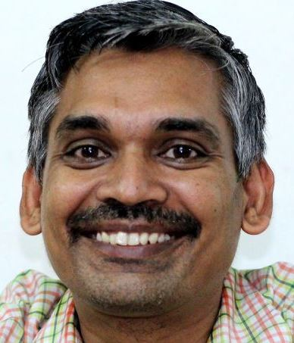
WGM Jana Krivec  Slovenia  Chess Psychology | GM Jan Timman  Netherlands  World Champions | GM Ramachandran Ramesh India  Creating Champions
 |  | 
GM Gun. Kjartansson  Iceland  Tactical Themes | GM L.D. Nisipeanu  Romania  Secrets of Dynamic Play | IM Jovan Petronic  Serbia  Strategy Analysis

Description of the Program

● Group A - Over 1900 Rating: Monday 18:00-20:05 CET (Juniors/Girls U16)
● Group B - Under 1900 rating: Tuesday 18:00-20:05 CET (Juniors/Girls U20)

● The Program will start on Monday November 18th, 2024, and the Lectures will be conducted via the Zoom platform.
● Each group will have 24 live sessions for a total of 48 hours of instruction.
● Participants will have the opportunity to watch the lectures and recordings for a limited time if they are unable to watch all the live sessions.
● Each live session will include 20 minutes of questions and answers.
● The program is based on the new ECU-ETC Trainers’ Syllabuses and aims to systematically develop chess talents.
● The program includes world-renowned trainers who work with the chess prodigies of the modern chess era.

Participation/Registration

● Each European National Chess Federations is entitled to register free of charge 2 Junior/Girls; one on each Group through the following link: https://forms.gle/SmcKgbRzYCKsxw8j8.
● The program is open for a limited number of additional participants, from all continents, for each group. The cost is only Euros 200 for 48 hours of top-level training.
● Registrations of additional participants are made through the following link: https://forms.gle/kcMU21LVNi9c1aSq9.
● Payments for additional participants (pre-paid) are made online here: https://www.europechess.org/ecu-payments-donations (select: ECU Academy).
● Or through the ECU Bank account mentioning the name of participant.

Certification & Info

● Each participant will receive an ECU-ETC official Certificate for the respective group upon completion of the programme - a plus point for a future chess career.
● For any question please contact: trainers@europechess.org

The program is supported by the
FIDE Development Fund
European Chess Union Academy - Schedule
Program | Day | Date | CET | Lecturer | Type
Group A - O.1900 | Monday | 18.11.2024 | 18:00-20:05 | Grivas Efstratios | Endgame Magic
Group B - U.1900 | Tuesday | 19.11.2024 | 18:00-20:05 | Gundmundur Kjartansson | Tactical Themes
Group A - O.1900 | Monday | 25.11.2024 | 18:00-20:05 | Ramachandran Ramesh | Creating Champions
Group B - U.1900 | Tuesday | 26.11.2024 | 18:00-20:05 | Petronic Jovan | Strategy Analysis
Group A - O.1900 | Monday | 02.12.2024 | 18:00-20:05 | Grivas Efstratios | Endgame Magic
Group B - U.1900 | Tuesday | 03.12.2024 | 18:00-20:05 | Nisipeanu Liviu-Dieter | Secrets of Dynamic Play
Group A - O.1900 | Monday | 09.12.2024 | 18:00-20:05 | Timman Jan | World Champions
Group B - U.1900 | Tuesday | 10.12.2024 | 18:00-20:05 | Stefanova Antoaneta | Playing on the Top
Group A - O.1900 | Monday | 16.12.2024 | 18:00-20:05 | Illescas Miguel | Tactical World
Group B - U.1900 | Tuesday | 17.12.2024 | 18:00-20:05 | Sokolov Ivan | Middlegame Strategy
Group A - O.1900 | Monday | 23.12.2024 | 18:00-20:05 | Mikhalchishin Adrian | Pawn Structures
Group B - U.1900 | Tuesday | 24.12.2024 | 18:00-20:05 | Ramachandran Ramesh | Creating Champions
Group A - O.1900 | Monday | 30.12.2024 | 18:00-20:05 | Sokolov Ivan | Middlegame Strategy
Group B - U.1900 | Tuesday | 31.12.2024 | 18:00-20:05 | Stefanova Antoaneta | Playing on the Top
Group A - O.1900 | Monday | 06.01.2025 | 18:00-20:05 | Krivec Jana | Chess Psychology
Group B - U.1900 | Tuesday | 07.01.2025 | 18:00-20:05 | Mikhalchishin Adrian | Pawn Structures
Group A - O.1900 | Monday | 13.01.2025 | 18:00-20:05 | Nisipeanu Liviu-Dieter | Secrets of Dynamic Play
Group B - U.1900 | Tuesday | 14.01.2025 | 18:00-20:05 | Petronic Jovan | Strategy Analysis
Group A - O.1900 | Monday | 20.01.2025 | 18:00-20:05 | Timman Jan | World Champions
Group B - U.1900 | Tuesday | 21.01.2025 | 18:00-20:05 | Illescas Miguel | Tactical World
Group A - O.1900 | Monday | 27.01.2025 | 18:00-20:05 | Gundmundur Kjartansson | Tactical Themes
Group B - U.1900 | Tuesday | 28.01.2025 | 18:00-20:05 | Krivec Jana | Chess Psychology
Group A - O.1900 | Monday | 03.02.2025 | 18:00-20:05 | Sokolov Ivan | Middlegame Strategy
Group B - U.1900 | Tuesday | 04.02.2025 | 18:00-20:05 | Gundmundur Kjartansson | Tactical Themes
Group A - O.1900 | Monday | 10.02.2025 | 18:00-20:05 | Ramachandran Ramesh | Creating Champions
Group B - U.1900 | Tuesday | 11.02.2025 | 18:00-20:05 | Petronic Jovan | Strategy Analysis
Group A - O.1900 | Monday | 17.02.2025 | 18:00-20:05 | Grivas Efstratios | Endgame Magic
Group B - U.1900 | Tuesday | 18.02.2025 | 18:00-20:05 | Nisipeanu Liviu-Dieter | Secrets of Dynamic Play
Group A - O.1900 | Monday | 24.02.2025 | 18:00-20:05 | Timman Jan | World Champions
Group B - U.1900 | Tuesday | 25.02.2025 | 18:00-20:05 | Stefanova Antoaneta | Playing on the Top
Group A - O.1900 | Monday | 03.03.2025 | 18:00-20:05 | Mikhalchishin Adrian | Pawn Structures
Group B - U.1900 | Tuesday | 04.03.2025 | 18:00-20:05 | Sokolov Ivan | Middlegame Strategy
Group A - O.1900 | Monday | 10.03.2025 | 18:00-20:05 | Illescas Miguel | Tactical World
Group B - U.1900 | Tuesday | 11.03.2025 | 18:00-20:05 | Gundmundur Kjartansson | Tactical Themes
Group A - O.1900 | Monday | 17.03.2025 | 18:00-20:05 | Stefanova Antoaneta | Playing on the Top
Group B - U.1900 | Tuesday | 18.03.2025 | 18:00-20:05 | Grivas Efstratios | Endgame Magic
Group A - O.1900 | Monday | 24.03.2025 | 18:00-20:05 | Krivec Jana | Chess Psychology
Group B - U.1900 | Tuesday | 25.03.2025 | 18:00-20:05 | Mikhalchishin Adrian | Pawn Structures
Group A - O.1900 | Monday | 31.03.2025 | 18:00-20:05 | Nisipeanu Liviu-Dieter | Secrets of Dynamic Play
Group B - U.1900 | Tuesday | 01.04.2025 | 18:00-20:05 | Petronic Jovan | Strategy Analysis
Group A - O.1900 | Monday | 07.04.2025 | 18:00-20:05 | Timman Jan | World Champions
Group B - U.1900 | Tuesday | 08.04.2025 | 18:00-20:05 | Illescas Miguel | Tactical World
Group A - O.1900 | Monday | 14.04.2025 | 18:00-20:05 | Ramachandran Ramesh | Creating Champions
Group B - U.1900 | Tuesday | 15.04.2025 | 18:00-20:05 | Krivec Jana | Chess Psychology
Group A - O.1900 | Monday | 21.04.2025 | 18:00-19:00 | Sokolov Ivan | Middlegame Strategy
 |  |  | 19:05-20:05 | Grivas Efstratios | Endgame Magic
Group B - U.1900 | Tuesday | 22.04.2025 | 18:00-19:00 | Mikhalchishin Adrian | Pawn Structures
 |  |  | 19:05-20:05 | Ramachandran Ramesh | Creating Champions
Group A - O.1900 | Monday | 28.04.2025 | 18:00-19:00 | Timman Jan | World Champions
 |  |  | 19:05-20:05 | Nisipeanu Liviu-Dieter | Secrets of Dynamic Play
Group B - U.1900 | Tuesday | 29.04.2025 | 18:00-19:00 | Illescas Miguel | Tactical World
 |  |  | 19:05-20:05 | Stefanova Antoaneta | Playing on the Top

